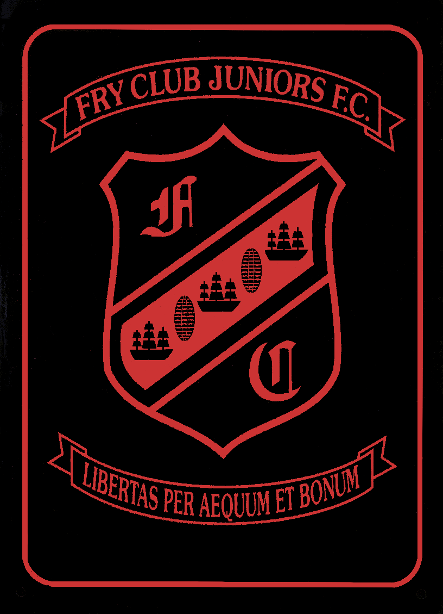

FRY CLUB JUNIOR FC AGM MEETING TO BE HELD AT FRY CLUB ON MONDAY 25th JUNE 2012

NOTICE OF THE FRY CLUB JFC AGM, TO BE HELD AT FRY CLUB ON MONDAY THE 25th OF JUNE 2012, STARTING AT 8:00.

Any nominations for selection to the committee to be forwarded to the secretary by no later than, Friday the 22nd of June 2012.

Any Resolutions to be considered at the AGM to be with the Secretary by Friday the 22nd of June 2012.

Secretary can be contacted via email at dave.worlock@btinternet.com

